# Exercise: Box Model and Position

Problems for exercises and homework for the ["HTML and CSS" course @ SoftUni](https://softuni.bg/courses/html-and-css).

## Box Model Container

Create a web page like the following:

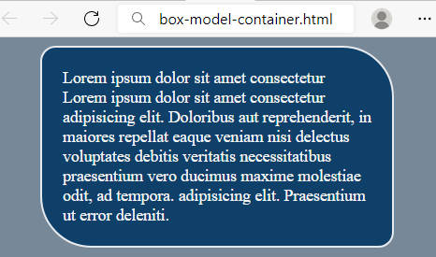

### Requirements

You will be given a skeleton with **filled** **HTML** and an **empty** **CSS** file. Write the missing **CSS** following the guidelines in the task.

* <body>:
  + Background color: **lightslategray**
* <p>:
  + Width: 300px
  + Paddings: 20px
  + **Auto** margins
  + Background color: **#0F4069**
  + Text color: **whitesmoke**
  + Solid border with size 2px and color #e6eaef
  + Top left and bottom right border radius: **15px**
  + Top right and bottom left border radius: **50px**

## Scrolling Article

Create a web page like the following:

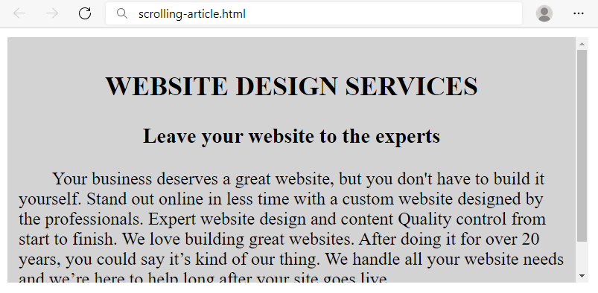

### Requirements

HTML with <body> that contains: <section> with <article> which has <h2>, <h3> and <p>.

CSS:

* <article>:
  + Width: **500px**
  + Height: **200px**
  + Background color: **lightgray**
  + Paddings: **10px**
  + **Auto** overflow
* <h2>:
  + All characters to be **UPPERCASE**
  + Align the **text** to the **center**
* <h3>:
  + Align the **text** to the **center**
* <p>:
  + Indent text in the first line 30px

## Brazil Coffee

Create a web page like the following:

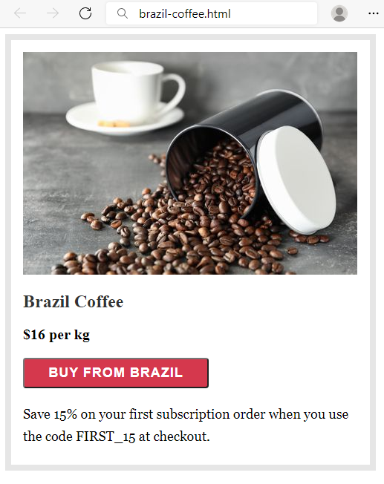

### Requirements

HTML with <body> that contains: <section> which has <img>, <h2>, <div>, <button> and <p>.

CSS:

* <section>:
  + Solid border with size 8px and color #e6e6e6
  + Paddings: **16px**
  + Width: **451px**
  + Height: **540px**
* <h2>:
  + Font: **Merriweather**
  + Generic Font: **serif**
  + Font weight **700**
  + **Top** & bottom margin 1.2rem
  + **Left** & **right** margin 0
  + Color: rgb(51, 51, 51)
* <div>:
  + Font weight **600**
  + Font size: **20px**
* <button>:
  + Width: **250px**
  + Font : **Work Sans**
  + Generic Font: **sans-serif**
  + Font weight **600**
  + Font size: **18px**
  + Border radius: **4px**
  + Background color: #**d5384d**
  + Text color: **#fff**
  + Letter spacing: **1px**
  + Align the **text** to the **center**
  + **Top** & bottom padding 8px
  + **Left** & **right** padding 16px
  + Top margin: **20px**
  + Bottom margin: **20px**
* <p>:
  + Fonts: **Georgia**, **Cambria**, **Times** **New** **Roman**, **Times**
  + Generic Font: **serif**
  + Font size: **18px**
  + Height of the line: 30px
  + Top margin: **0**

## Article

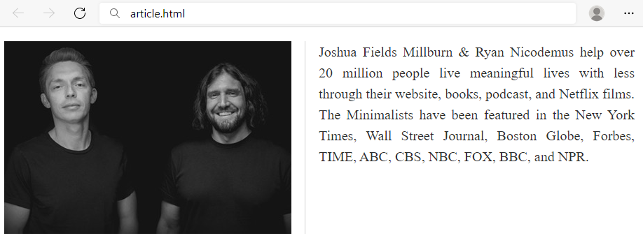

### Requirements

You will be given a skeleton with **filled** **HTML** and an **empty** **CSS** file. Write the missing **CSS** following the guidelines in the task.

* <main>:
  + Width: **900px**
  + Height: **140px**
* <img>:
  + Solid **right** border with size 1px and color **#d1d1d1**
  + Float the images on the **left**
  + Right margin: **19px**
  + Right padding: **19px**
* <p>:
  + Font size: **20px**
  + Height of the line: 30px
  + Text color: #2e2e2e
  + Text align: justify

## Blog Article

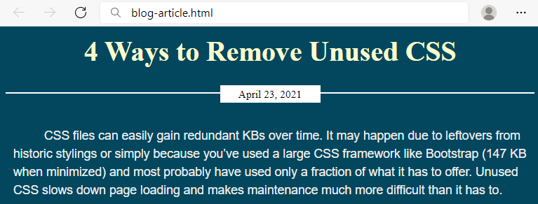

### Requirements

You will be given a skeleton with **filled** **HTML** and an **empty** **CSS** file. Write the missing **CSS** following the guidelines in the task.

* <body>:
  + Background color: **#02475e**
* **<article> :**
  + <h2>:
    - Font size: **36px**
    - Text color: **#fefecc**
    - Margins: **12px**
    - Align the text to the **center**
  + <p>:
    - Text color: **#eee**
    - Font: **Arial**
    - Generic Font: **sans-serif**
    - Height of the line: **24px**
    - Paddings: **10px**
    - Indent text in the first line **30px**
  + <div>:
    - Bottom margin: **30px**
    - Solid **top** border with size 2px and color **#fff**
    - **Relative** position
    - Top coordinates: **20px**
  + <span>:
    - Width: **120px**
    - Font size: **14px**
    - Align the **text** to the **center**
    - **Top** & bottom paddings 3px
    - **Left** & **right** paddings 5px
    - **Top** & bottom margins 0
    - **Left** & **right** margins **auto**
    - Background color: **#fff**
    - Display the span as **block**
    - **Relative** position
    - Top coordinates: -**11px**

## Navigation Inline Block

Create a web page like the following:

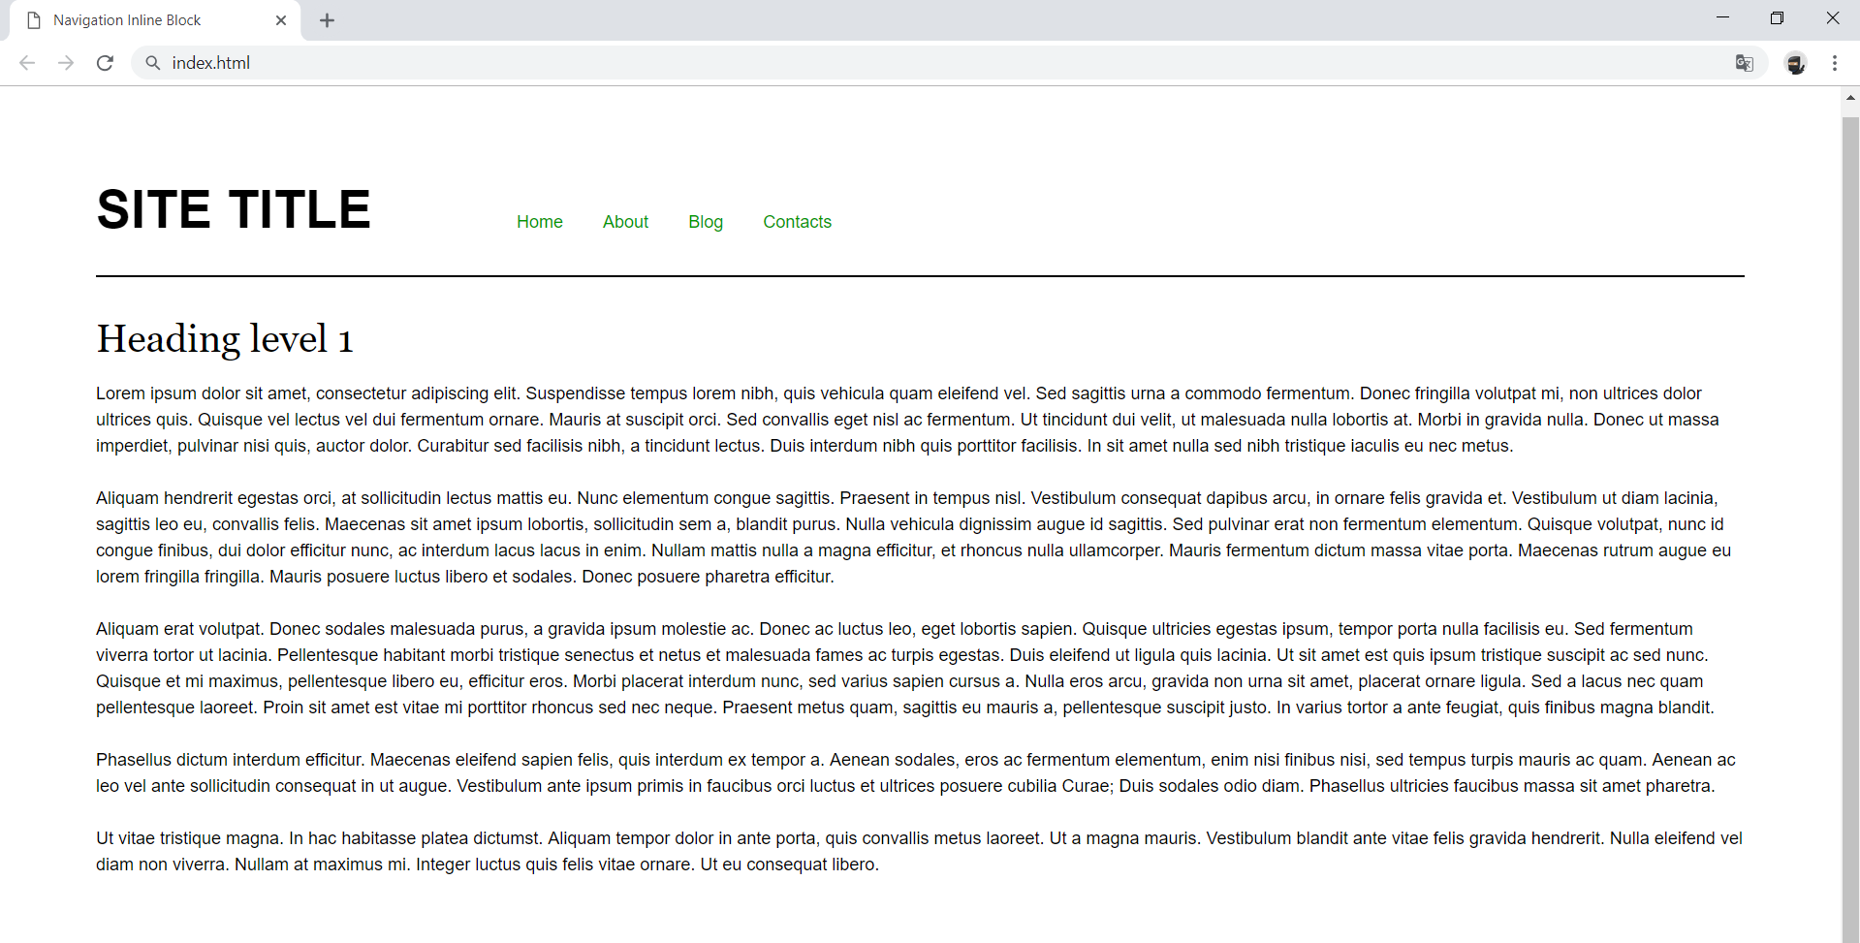

### Requirements

* Change the document title to "**Navigation Inline Block**"
* Divide your content into header and main tags
* Add font to the document: **Helvetica**, **sans-serif**
* Create a navigation bar
  + Add four list items in nav tag with a tags inside
  + Add display: inline-block; style for each item in the nav

## Make Your Own Website

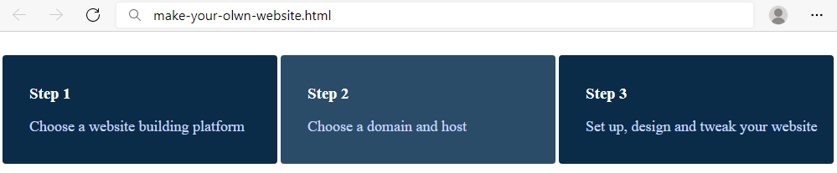

### Requirements

You will be given a skeleton with **filled** **HTML** and an **empty** **CSS** file. Write the missing **CSS** following the guidelines in the task.

* <div>:
  + Width: **280px**
  + Display the divs as **inline-block**
  + Padding top, right and bottom: **16px**
  + Padding left: **32px**
  + Top margin: **20px**
  + Background color: **#0A2C48**
  + Text color: **#fff**
  + Radius of the border: **4px**
* <div>on mouse **hover:**
  + Background color: **#2A4C68**
* <p>:
  + Text color: **#c9d6ff**
  + Font size: 18px

## Photo Gallery Inline Block

Create a web page like the following:

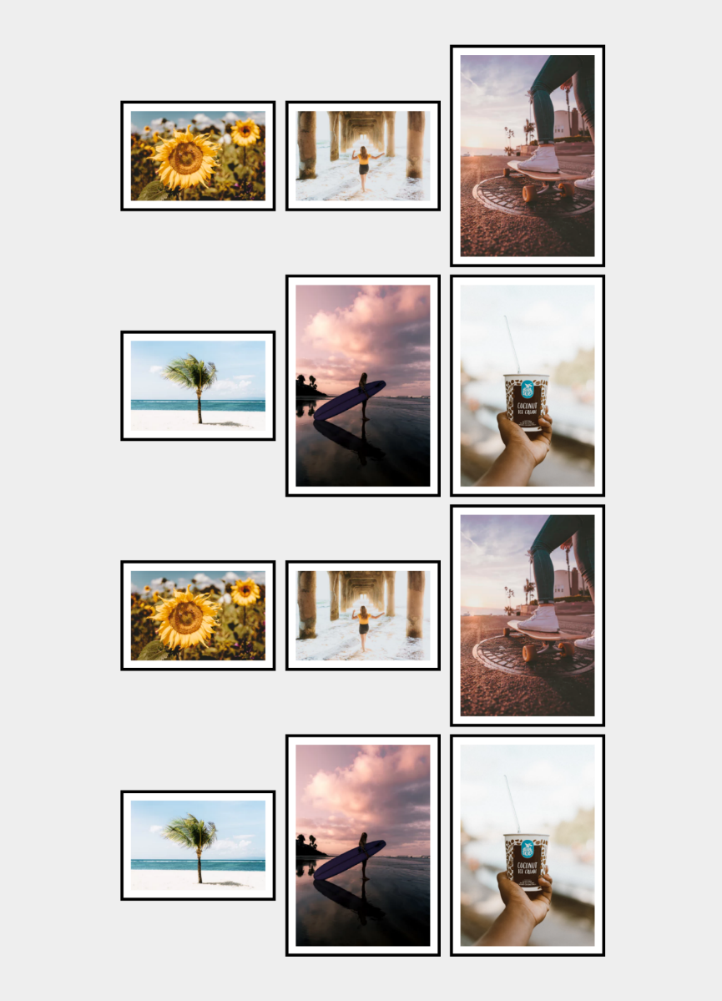

### Requirements

* Change the document title to "**Photo Gallery - Inline Block**"
* Create unordered list with **class** gallery (ul.gallery)
* Add list items with images inside
* **<body>**
  + Padding: **5rem**
  + Background color: **#eee**
* **.gallery**
  + Width: **100%**
  + Margin**: 0 auto**
  + Align the text to the **center**
* **li**
  + Width: **18rem**
  + Display the list as **inline-block**
  + Background color: **#fff**
  + Solid border with size 0.4rem and color **#000**
  + Padding: **1rem**
  + Vertical align: **middle**
  + Margin: **0.5rem**
* **img**
  + display: **block**
  + width: **100%**
  + height: **auto**

## Blog Layout Inline Block

Create a web page like the following:

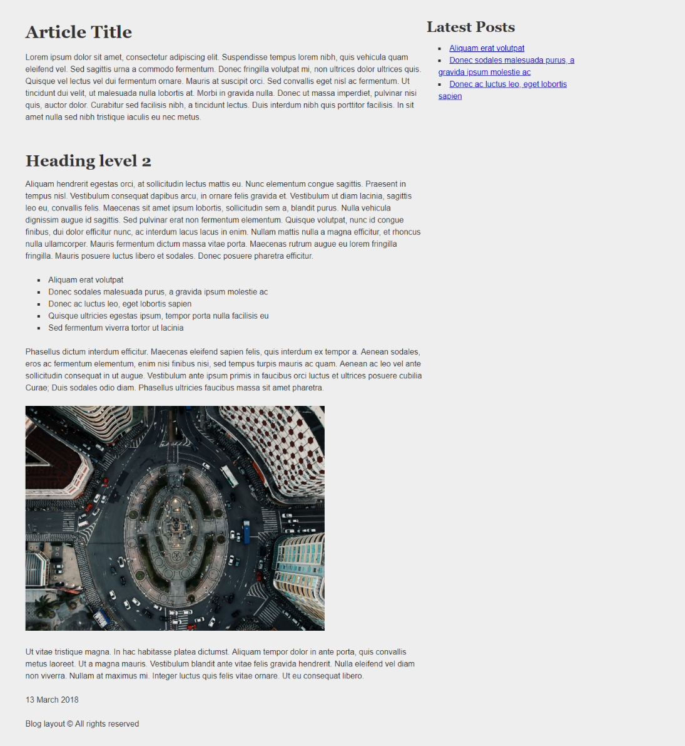

### Requirements

* Change the document title to "**Blog Layout Inline Block**"
* Add font to the document: **Helvetica**, **sans-serif**
* Use article tag to create an article
  + Divide the article content into header, section and footer tags
* Use aside tag to create aside for the **Latest** **Posts**
* Use background with color - rgb(238, 238, 238)
* Use rgb(51, 51, 51) color for the text

## Position Playground

Create a web page like the following:

Картина, която съдържа екранна снимка, изкуство

Описанието е генерирано автоматично

* Change the document title to "**Positioning Playground**"
* Import [Font Awesome](https://fontawesome.com/) into your **CSS** file

**Requirements**

* Add two container units **(**divs**)** with class viewport inside the body
  + Inside each one adds section with class card *(*section.card*)*
    - Change the display property to block
    - Try to center the section with position property absolute

## Center Position and Transform

Create a web page like the following:

Картина, която съдържа текст, екранна снимка, лого, Марка

Описанието е генерирано автоматично

* Change the document title to "**Center Position and Transform**"

**Requirements**

* **Section** tag must have **class="card"**
* Create section with two divs
  + First div contains image
  + Second div contains**: <h3>**, **<p>** and **a** tags
* Use rgb(238, 238, 238) for body background
* Use rgb(255, 255, 255) for card background
* Use rgb(0, 153, 0) for card button background
* Use font Georgia, serif with size 1em/1.2 for the headings
* Set the image position property to absolute

## Navigation

Create a web page like the following:

Картина, която съдържа текст, екранна снимка, документ, дизайн

Описанието е генерирано автоматично

* Change the document title to "**Navigation**"

**Requirements**

* Create a header with a p for as title
  + Inside the header add a nav with a ul and 4 li elements
* Create a main, which contains an article with a header and h1 heading
  + Add a section inside the article
* Create an aside element with two sections inside
  + The sections should have a h3 heading and a navigation - nav with ul, li and a elements
* Use rgb(0, 102, 0) for the anchors
* Use rgb(238, 238, 238) for body background
* Use rgb(255, 255, 255) for image background and rgba(0, 0, 0, 0.25) for image box shadow
* Use font Georgia, serif for the blockquote
* Use font Georgia, serif with size 1em/1.2 for the headings

## New Offer

Create a web page like the following:

Картина, която съдържа екранна снимка, кафена чаша, чаша, дизайн

Описанието е генерирано автоматично

**Requirements**

HTML with <body> that contains <main> and two <img>.

<img> with new.png need class="new".

CSS:

* <main>:
  + Width: **700px**
  + Height: **500px**
  + Margins: **60px**
* img.new:
  + **Relative** position
  + Top coordinates: **-200px**
  + Right coordinates: **150px**

## Social Media Icons

Create a web page like the following:

Картина, която съдържа бял, черен, дизайн

Описанието е генерирано автоматично

* Change the document title to "**Social Media Icons**"
* Use FontAwesome to add social icons

**Requirements**

* All you need for your HTML are ul, li and a tags
* Change the ul display property to inline-block
* Remove list items default style
* Each a tag must have border-radius: 50%;
* Check the provided screenshots to see the hover effects

## Interior Design Studio

Create a webpage like the following:

Картина, която съдържа обзавеждане, интериорен дизайн, текст, диван

Описанието е генерирано автоматично

**Requirements**

HTML with <body> that contains <h1> and <img>.

CSS:

* <h1>
  + **Absolute** position
  + **Top** coordinates: **60px**
  + **Left** coordinates: **180px**
  + Text color: **antiquewhite**
  + text-shadow: 1px 1px 20px black;

## Jewellery Website

Картина, която съдържа човек, Човешко лице, мигла, кожа

Описанието е генерирано автоматично

**Requirements**

You will be given a skeleton with **filled** **HTML** and an **empty** **CSS** file. Write the missing **CSS** following the guidelines in the task.

* <section>
  + Set the position to **absolute**
  + Use the **coordinates**: **250px** and **180px** to position the **frame** correctly
* <h3>
  + Font size: **16px**
  + Margin: **0px**
* <span>
  + Padding left: **3px**
  + Text color: **gray**
  + Font size: **14px**
* <div>
* Set the position to **relative**
* Use the **coordinates**: **50px** and **8px** to position the **text** correctly